**Advanced Graphics Programming** Project 3 (OpenGL) - June 2020

| * The submission deadline is **June 7th at 23:59:59**. * The **live presentation (prepare a few slides)** will be on **June 8th at 8:30am.** * Use **GitHub** for code maintenance and project versioning. * To deliver the exercise, **create a GitHub release** and upload a **link to the release page** into the ATENEA campus: **Project 3 - Advanced Graphics Techniques** folder. * **If it does not compile or execute, the exercise won’t be accepted.** |
| --- |

## Statement

Implement a 3D model viewer that implements some of the computer graphics techniques seen in class. That will imply the extensive use of mathematical operations and OpenGL objects that handle data in the GPU (such as vertex buffers with geometry information, shader programs, textures, and framebuffer objects) and its proper management and coordination through a rendering pipeline that connects the several algorithms developed.

## 

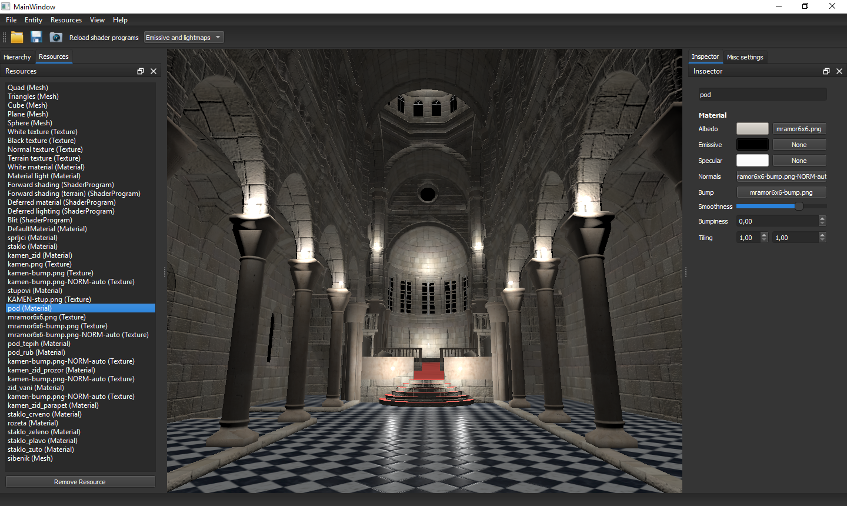 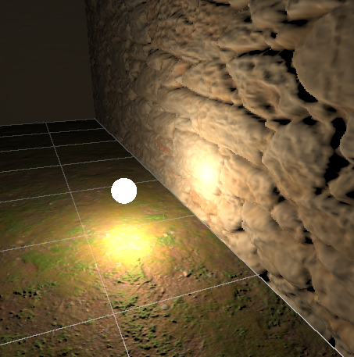 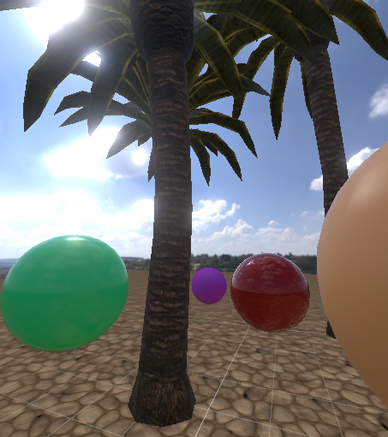

## Application requirements

The application will have to:

* Implement these scene interaction techniques **(2 points)**.
  + Orbital camera around the pivot point
  + Move camera around the scene using WASD + mouse
* Implement a deferred shading pipeline **(2 points)**
* Combo box to switch between forward and deferred shading **(1 point)**
* Implement **at least two** of the following effects **(5 points)**
  + Relief mapping
  + SSAO
  + Water effect
  + Multi-pass bloom
* Not seen in class but will be positively evaluated
  + Environment mapping (skybox, fake reflections, and diffuse IBL)
  + PBR + PBR IBL (includes environment mapping)
  + Procedural editor grid

## Documentation requirements

The documentation has to be presented in a markdown file (**README.md**) provided in the root folder of the repository in GitHub so that it can be seen from a web browser. It will contain the following information:

* Names of the group members
* List of techniques implemented:
  + To show the effect of each technique, show a couple of renders from the same point of view, with each technique enabled and disabled.
  + Explain how to enable / disable / configure the options you may have.
  + Include screenshots of the corresponding widgets when appropriate.
  + Name of shader files for every effect

## Presentation requirements

The presentation should last at least a couple of minutes, and should be performed by both members of the team, whenever possible. It will be held online and should include:

* The description of the techniques implemented
  + How you implemented them (general idea)
  + The difficulties encountered
  + Feedback
  + Why you chose them, etc
* Prepare for questions